**Roman Forum** 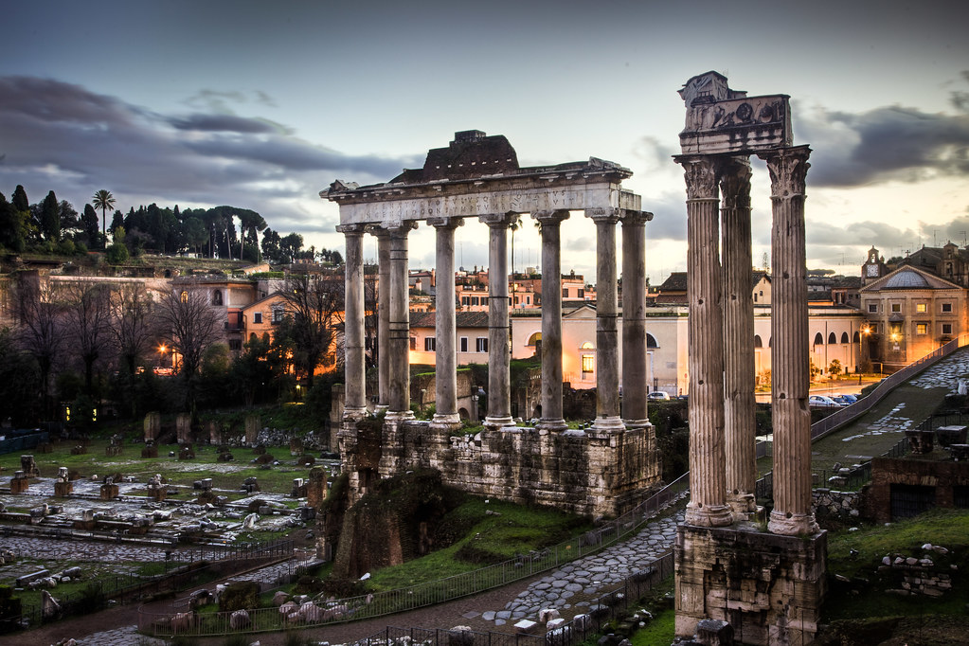

The **Roman Forum** ([Italian](https://en.wikipedia.org/wiki/Italian_language): *Foro Romano*), also known by its [Latin](https://en.wikipedia.org/wiki/Latin) name **Forum Romanum**, is a rectangular [forum](https://en.wikipedia.org/wiki/Forum_(Roman)) ([plaza](https://en.wikipedia.org/wiki/Plaza)) surrounded by the ruins of several important ancient government buildings at the centre of the city of [Rome](https://en.wikipedia.org/wiki/Rome). Citizens of the ancient city referred to this space, originally a marketplace, as the *Forum Magnum*, or simply the *Forum*.

For centuries, the Forum was the centre of day-to-day life in Rome: the site of [triumphal processions](https://en.wikipedia.org/wiki/Roman_triumph) and elections; the venue for public speeches, [criminal trials](https://en.wikipedia.org/wiki/Roman_litigation) and [gladiatorial matches](https://en.wikipedia.org/wiki/Gladiator); and the nucleus of commercial affairs. Here statues and monuments commemorated the city's leaders. The heart of [ancient Rome](https://en.wikipedia.org/wiki/Ancient_Rome), it has been called the most celebrated meeting place in the world, and in all history.[[3]](https://en.wikipedia.org/wiki/Roman_Forum#cite_note-3) Located in the small valley between the [Palatine](https://en.wikipedia.org/wiki/Palatine_Hill) and [Capitoline Hills](https://en.wikipedia.org/wiki/Capitoline_Hill), the Forum today is a sprawling ruin of architectural fragments and intermittent archaeological excavations attracting 4.5 million or more sightseers yearly.

Many of the oldest and most important structures of the ancient city were located on or near the Forum. The [Roman Kingdom](https://en.wikipedia.org/wiki/Roman_Kingdom)'s earliest shrines and temples were located on the southeastern edge. These included the ancient former royal residence, the [Regia](https://en.wikipedia.org/wiki/Regia" \o "Regia) (8th century BC), and the [Temple of Vesta](https://en.wikipedia.org/wiki/Temple_of_Vesta) (7th century BC), as well as the surrounding [complex of the Vestal Virgins](https://en.wikipedia.org/wiki/House_of_the_Vestals), all of which were rebuilt after the rise of [imperial Rome](https://en.wikipedia.org/wiki/Roman_Empire).

Other archaic shrines to the northwest, such as the [*Umbilicus Urbis*](https://en.wikipedia.org/wiki/Umbilicus_Urbis) and the [Vulcanal](https://en.wikipedia.org/wiki/Vulcanal" \o "Vulcanal) (Shrine of Vulcan), developed into the [Republic](https://en.wikipedia.org/wiki/Roman_Republic)'s formal [Comitium](https://en.wikipedia.org/wiki/Comitium" \o "Comitium) (assembly area). This was where the [Senate](https://en.wikipedia.org/wiki/Roman_Senate)—as well as [Republican government](https://en.wikipedia.org/wiki/Republican_government) itself—began. The Senate House, government offices, tribunals, temples, memorials and statues gradually cluttered the area.

Over time, the archaic [Comitium](https://en.wikipedia.org/wiki/Comitium" \o "Comitium) was replaced by the larger adjacent Forum, and the focus of judicial activity moved to the new [Basilica Aemilia](https://en.wikipedia.org/wiki/Basilica_Aemilia) (179 BC). Some 130 years later, [Julius Caesar](https://en.wikipedia.org/wiki/Julius_Caesar) built the [Basilica Julia](https://en.wikipedia.org/wiki/Basilica_Julia), along with the new [Curia Julia](https://en.wikipedia.org/wiki/Curia_Julia), refocusing both the judicial offices and the Senate itself. This new Forum, in what proved to be its final form, then served as a revitalized city square where the people of Rome could gather for commercial, political, [judicial](https://en.wikipedia.org/wiki/Roman_law) and [religious](https://en.wikipedia.org/wiki/Religion_in_ancient_Rome) pursuits in ever greater numbers.

Eventually, much economic and judicial business would transfer away from the *Forum Romanum* to the larger and more extravagant structures ([Trajan's Forum](https://en.wikipedia.org/wiki/Trajan%27s_Forum) and the [Basilica Ulpia](https://en.wikipedia.org/wiki/Basilica_Ulpia)) to the north. The reign of [Constantine the Great](https://en.wikipedia.org/wiki/Constantine_the_Great) saw the construction of the last major expansion of the Forum complex—the [Basilica of Maxentius](https://en.wikipedia.org/wiki/Basilica_of_Maxentius) (312 AD). This returned the political centre to the Forum until the fall of the [Western Roman Empire](https://en.wikipedia.org/wiki/Western_Roman_Empire) almost two centuries later.